**◇User Manual◇**

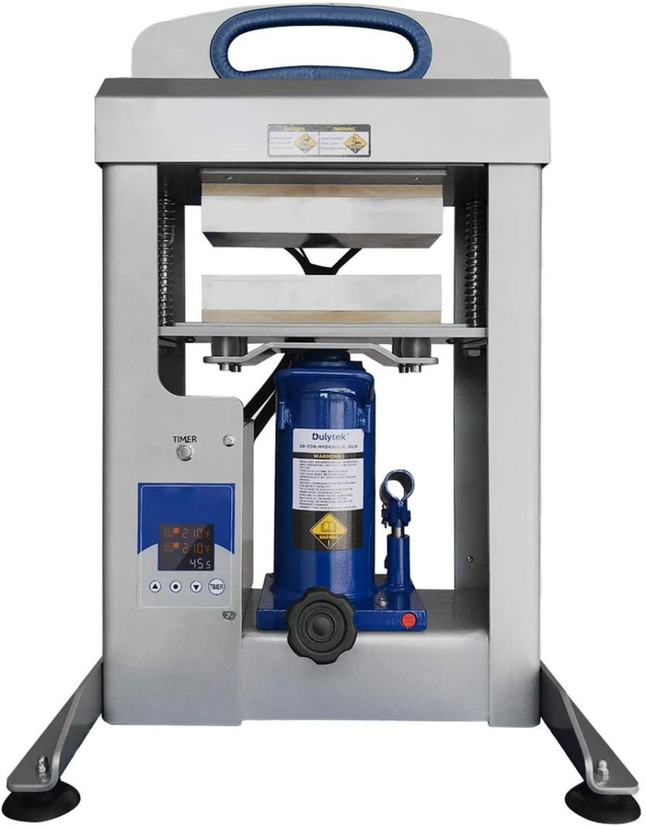

**Pump Handle**

**Socket**

**Pressure Release Knob**

**Top Platen**

**Bottom Platen**

**Timer Button**

**Control Panel**

**Components**

**Machine Handle**

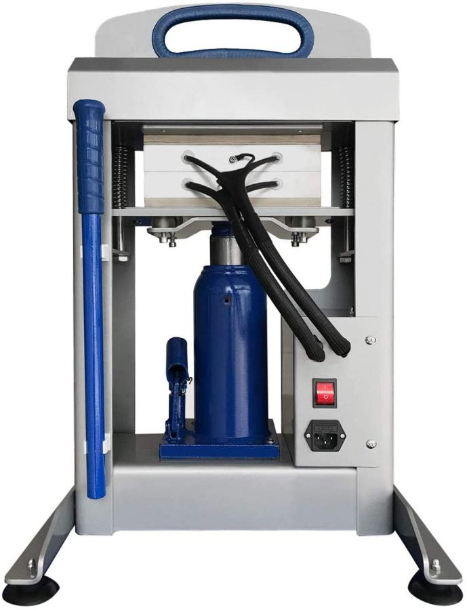

**ON / OFF Switch**

**AC Power Cord Socket**

**Pump Handle**

**Specification:**

**Item Code:** B5-15T

**Item Style:** Manual Hydraulic

**Size**: 7.5*20cm/3*8inch **Controller:** LED Control Panel

**Electric Data:** 220V 50Hz, 800W

**N.W.:** 48kg, **G.W.:** 54kg

**PKG:** 47*33*71cm

B5-15T Hydraulic Rosin Press is a machine engineered and manufactured for solvent-less plant rosin oil extraction for further use in research laboratories,pharmaceutical, cosmetic, food processing, and brewing industries.The extraction process involves pressing nugs of hemp between parchment paper with a heat press to extract the valuable hemp oil, it depends upon 4 things:

- Temperature

- Pressing Time

- Pressing Force

- Size/Weight of nugs

**1. Read Before Use**

1. Check the voltage before using it. Either 220V.

2. Turn off the machine when not in use, and remove the power plug from socket. Always Keep children away from the machine.

3. Do not touch the heating platen or platen cover after pressing whilst in operation.

5. Do not set the temperature any higher than 150℃/300℉, normal application temp. Is within 150℃/300℉.

**2. Recommended Accessories**

25 lb or Thicker 20x30cm Parchment Paper

5*10cm Filter Bag

Rosin Scraper Tools Set with Slicone Jar

1. **Recommended Operation Parameter**

Time: 30~40sec.

Temp.: 110~150℃/ 230~300℉

Pressure: Feel by feeling, when you feel the pressure is enough and hard to pressure down the jack handle.

**4.How to Use Rosin-tech Heat Press ?**

●Take out rosin press from package.

● Plug in the power socket, turn on the power switch ,set temp.&time for each control panel, Say. 240℉/110℃ 30sec. and raises to the set temp.

● Put the rosin hash or seeds into a filter bag

● Use parchemnt paper to cover the filter bag before placing on the lower heating element.

● Pump the jack handle to move the bottom platen up. Continue pumping until the desired pressure is reached. Release the handle.Press the timer ON / OFF button located above the control panel.

● Wait until the countdown ends and the timer starts beeping. Press the ON / OFF button again to turn off the timer.

● Turn the valve knob counterclockwise to release the press and lower

the bottom platen. Remove the pressed material using heat resistant gloves or tools and exercising extreme caution.

● Remove the pump handle from the pump handle socket.

● Turn the machine off by flipping ON / OFF switch when done pressing. Remove the plug from the socket.

● Wait until the press cools down completely to clean and store it.

**5.Setting Control Panel**

